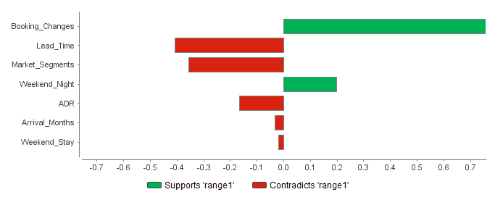

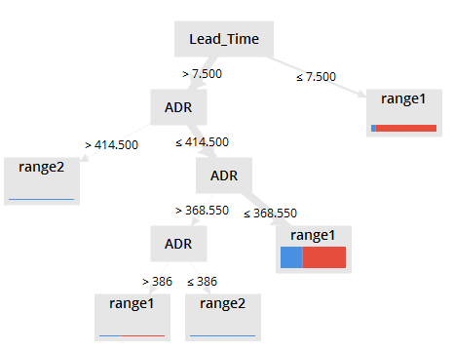

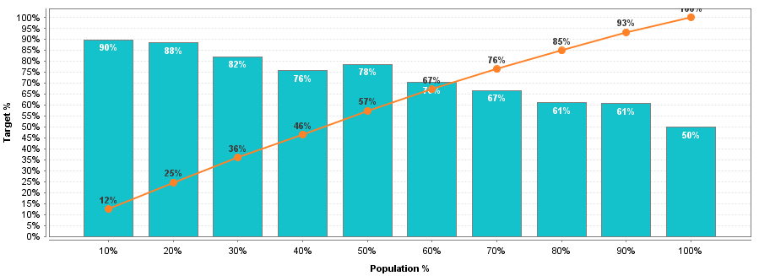

|  |  |  |  |  |  |  |  |  |
| --- | --- | --- | --- | --- | --- | --- | --- | --- |
| **Coefficientsa** | | | | | | | | |
| Model | | Unstandardized Coefficients | | Standardized Coefficients | t | Sig. | 95.0% Confidence Interval for B | |
| B | Std. Error | Beta | Lower Bound | Upper Bound |
| 1 | (Constant) | .184 | .004 |  | 49.666 | .000 | .176 | .191 |
| Weekend_Stay | .009 | .003 | .023 | 3.285 | .001 | .004 | .014 |
| Weekend_Night | -.005 | .001 | -.028 | -3.942 | .000 | -.008 | -.003 |
| Lead_Time | .001 | .000 | .233 | 44.037 | .000 | .001 | .001 |
| a. Dependent Variable: Booking_Status | | | | | | | | |

|  |  |  |  |  |  |  |  |  |  |  |  |
| --- | --- | --- | --- | --- | --- | --- | --- | --- | --- | --- | --- |
| **Model Summaryb** | | | | | | | | | | | |
| Model | R | R Square | Adjusted R Square | Std. Error of the Estimate | Change Statistics | | | | | Durbin-Watson |
| R Square Change | F Change | df1 | df2 | Sig. F Change |
| 1 | .230a | .053 | .053 | .436 | .053 | 747.682 | 3 | 40056 | .000 | .441 |
| a. Predictors: (Constant), Lead_Time, Weekend_Stay, Weekend_Night | | | | | | | | | | | |
| b. Dependent Variable: Booking_Status | | | | | | | | | | | |

|  |  |  |  |  |  |  |
| --- | --- | --- | --- | --- | --- | --- |
| **ANOVAa** | | | | | | |
| Model | | Sum of Squares | df | Mean Square | F | Sig. |
| 1 | Regression | 426.038 | 3 | 142.013 | 747.682 | .000b |
| Residual | 7608.122 | 40056 | .190 |  |  |
| Total | 8034.160 | 40059 |  |  |  |
| a. Dependent Variable: Booking_Status | | | | | | |
| b. Predictors: (Constant), Lead_Time, Weekend_Stay, Weekend_Night | | | | | | |

